Password Vault
Copyright © 2000

Table of Contents

Creating the first user login.

Logging into Password Vault

The Options Menu

Password Types & Properties

Features

How to contact HH Data Solutions

Password Vault Contents

Creating the first user login
When the program is executed for the first time you will be presented with a window (figure 1).
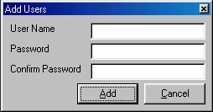
Figure 1
At this time you must enter a user name, password and a confirmation of that password. If you choose Cancel you will not be able to continue.

Logging into Password Vault
Once the user has been added the login screen will display (figure 2), you can logon the program. Notice that you have an Ok, New User, and Cancel button on the
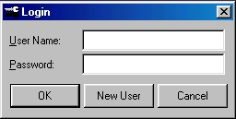
Figure 2
login window. Once you have entered your user name and password click on the Ok button. If you want to exit the application you can press the Cancel button. And if you want to create new users to use Password Vault (see license agreement) click on the New User button.

The Options Menu

Add Types
The Add Types submenu allows you to add different types of categories for your passwords. For example, if you have a password you would like to store for you e-mail account then you might want to have a category named e-mail. The program has already been shipped with the most common and frequently used categories but you have the option to add more.

Show Password
This allows you to view your password for the entry you have selected. As default your passwords are show with “*”.

Change Password
The Change Password submenu allows you to change your login password to Password Vault. This is something that you should do every 30 days if you use this program around others or if you feel that someone might now your password. As a general rule do not use your birthday, pet’s name, etc. for a password.

Password Types & Properties
Password Types have already been covered to some degree. Again the password types serve as a category for your passwords. If you have logons to different auction sites you might want to have a category for “Auction Sites”. When you select “Auction Sites” from the Password Types drop-down menu the list will only be those passwords that you entered in as a “Auction Site” type.
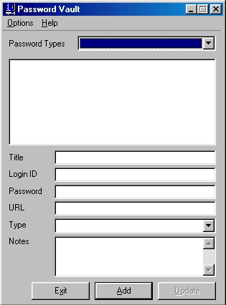
Figure 3
Below the list box are the properties you set for your stored data. You have a Title, Login ID, Password, URL, Type, and Notes. Here is an example of a stored entry:
Title My 401k
Login ID My Name
Password ************
URL N/A
Type Financial
Notes This document contains my 401k earnings.
Once you have entered data into the application and have click the Add button to add the record the list box will then populate with the Title of that entry. If you would like to see that entry double click on it in the list box and the fields will populate with the information you inputted earlier. You will notice the Add button is disabled and the Update button is enabled now. This allows you to make changes to the entry. Once you update the information the Update button is disabled and the Add button is enabled.
NOTE: If you leave a field empty the application will place a “0” in that field. This is done for security measures and to ensure data validity.

Features

Multiple Users
Varying on the license agreement you purchased will enable this feature. The feature was covered in Logging into Password Vault earlier. To learn more about how many users can access this program read the license agreement that was shipped / downloaded with the program.

Tray Icon
To let you have easier access to Password Vault a icon will be placed in your tray on your taskbar. This will enable you to minimize, restore, and exit the program.

Encryption
To keep your password data even more secure your password information is encrypted when stored. If you happen to forget your password to Password Vault you will not be able to access any data that you have entered into it.

Backup
The program also creates a backup of your password information every time you exit the program. This helps create a better since of security and a less of a chance of data loss. However, frequent backups are recommended and HH Data Solutions and its employees are not liable for any information that is lost, corrupted, or stolen.

How to contact HH Data Solutions

Internet:
http://www.hhdatasolutions.com/
mailto:customersupport@hhdatasolutions.com

FAX:
413-215-8554

Mail:
HH Data Solutions
PO Box 535053
Grand Prairie, TX 75053-5053

™
HH Data Solutions, HHDS Logo™ 2000
Password Vault © 2000

